Ex. No:6 | Manage Kubernetes Resources Using CLI
18-09-2025

Aim
Learn to install the tools and manage basic Kubernetes resources using the kubectl.

Description
Docker: Used to store and run the prebuilt Python web application container image.

- It ensures that the app runs the same way on any system — from development to production.

- Containers start faster and use fewer resources compared to virtual machines.

- In this experiment, Docker hosts the Python web app image (e.g., dockersamples/flaskapp) that is later deployed in Kubernetes.

kubectl: Command-line interface to manage Kubernetes objects such as Deployments and Services.

- It allows you to create, update, inspect, and delete Kubernetes resources like Pods, Deployments, and Services.

- You can use it to scale applications, view logs, check rollout status, and troubleshoot issues.

- In this lab, kubectl was used to apply deployment and service YAML files, check pod status, and expose the app.

Minikube: Provides a local single-node Kubernetes cluster for development and testing.

- It’s designed for learning, testing, and development before deploying to a full Kubernetes environment.

- It integrates with Docker to create and manage local clusters using drivers like Docker or VirtualBox.

- In this lab, Minikube started the local cluster, hosted the Python app deployment, and provided a service URL to access the running application.

Prerequisites

Before starting the lab, you need:

- A laptop or VM with Docker and Docker Compose installed.
- Operating system: Ubuntu/Debian Linux, macOS, or Windows 10/11.
- Basic terminal or PowerShell knowledge.
- Admin/sudo access to install tools.
- Docker and Minikube installed and running.

Procedure

STEP 1 — Install kubectl

Windows (using Chocolatey):

choco install kubernetes-cli

Verify installation:

kubectl version --client

STEP 2 — Install and Start Minikube

Windows (using Chocolatey):

choco install minikube

minikube start --driver=docker

Verify the cluster is running:

minikube status

kubectl get nodes

STEP 3 — Create a Simple Pod

apiVersion: v1

kind: Pod

metadata:

name: nginx-pod

labels:

app: nginx

spec:

containers:

- name: nginx

image: nginx:latest

ports:

- containerPort: 80

Apply the manifest:

kubectl apply -f nginx-pod.yaml

Check pod status:

kubectl get pods

# expected: nginx-pod 1/1 Running

Describe the pod (to see detailed info):

kubectl describe pod nginx-pod

Forward the port locally to access it in the browser:

kubectl port-forward pod/nginx-pod 8080:80

Then open http://localhost:8080 in your browser.

STEP 4 — Deployment and Scaling
Create a deployment:
kubectl create deployment my-nginx --image=nginx

Check deployments and pods:
kubectl get deployments
kubectl get pods -l app=my-nginx

Scale to 3 replicas:
kubectl scale deployment my-nginx --replicas=3
kubectl get pods

Update the image (rolling update):
kubectl set image deployment/my-nginx nginx=nginx:1.25
kubectl rollout status deployment/my-nginx

STEP 5 — Expose Deployment as a Service
Expose the deployment using a NodePort service:
kubectl expose deployment my-nginx --type=NodePort --port=80
kubectl get svc

Get the URL of your app using Minikube:
minikube service my-nginx --url

Open the displayed URL in your browser.

To remove the service:
kubectl delete svc my-nginx

STEP 6 — Cleanup
After the lab, clean up all created resources:
kubectl delete deployment my-nginx
kubectl delete svc my-nginx
kubectl delete all --all -n default

If you want to stop or delete the cluster:
minikube stop
minikube delete

Output

minikube start --driver=docker

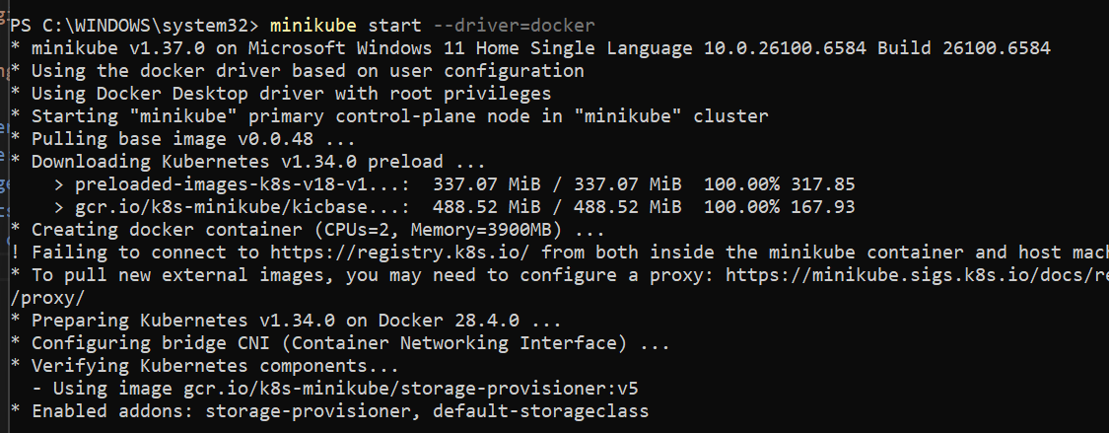

Checking Status of Minikube

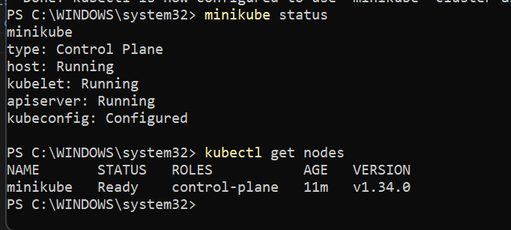

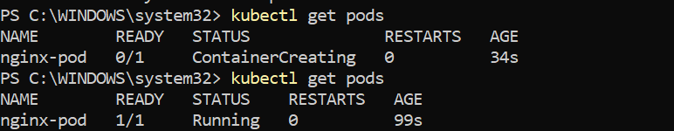

Accessing the URL of your app using Minikube:

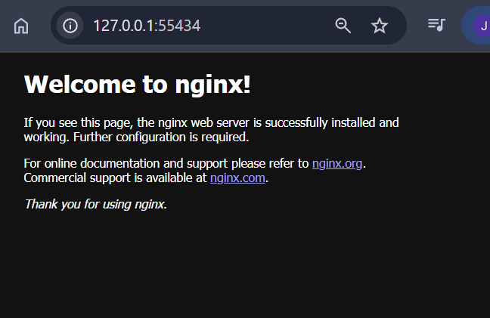

Deleting all services:

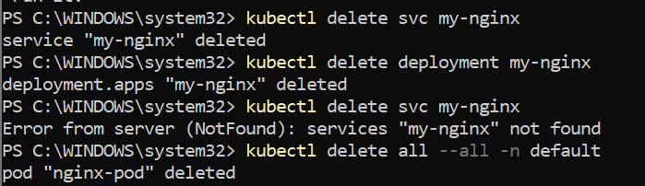

Result
Successfully created, scaled, and exposed an Nginx application on a local Kubernetes cluster using kubectl.

